# Cygwin Install Notes for Windows Server 2012

## Prerequisites

Make sure the following components are installed on your VM:

* [Java SE](http://www.oracle.com/technetwork/java/javase/downloads/index.html)
* [Eclipse](http://www.eclipse.org/downloads/packages/)

## Install Cygwin

Cygwin SSH server is an emulation of the UNIX environment and OpenSSH for Windows. This is needed to run Hadoop scripts as they are all written for UNIX platform.

1. Download Cygwin setup from [here](http://cygwin.com/setup.exe)
2. Run the *setup.exe* file and click **Next** to proceed
3. On the *Choose Installation Type* screen, select **Install from Internet**, then click **Next**
4. On the *Choose Installation Directory* screen, enter **C:\cygwin** as the Root Directory, and click **Next**
5. On the *Select Local Package Directory* screen, select a directory on your local machine (Example: C:\Packages) to store the downloaded installation files, and click **Next**
6. On the *Select Connection Type* screen, select appropriate settings to connect to the internet, and click **Next**
7. On the *Choose Download Site(s)* screen, select any site from the available list, and click **Next**
8. On the *Select Packages* screen, ensure that you select the following packages, and click **Next** -

From the **Archive** category, select **unzip** and **zip** as follows:

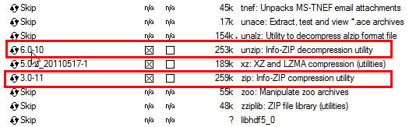

From the **Net** category, select **openssh** and **openssl** as follows:

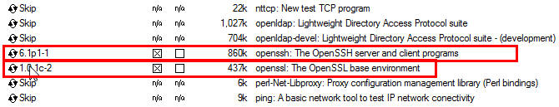

After selecting the packages and clicking **Next,** the Resolving Dependencies screen is displayed. Click **Next** to proceed.

1. On the Installation Status and Create Icons screen, do not make any changes. Click Finish to complete the installation process.
2. Final step is to set the Environment Variables. Add the following **c:\cygwin\bin;c:\cygwin\usr\bin** to Path

## Configure SSH

Hadoop scripts and Eclipse plugin require ssh authentication through authorization keys rather than through passwords. To enable key based authorization follow the steps given below:

1. To verify if Cygwin is installed properly, run **Cygwin.bat** and execute the following command

|  |
| --- |
| cygrunsrv –h |

1. To install the **sshd service**, run

|  |
| --- |
| ssh-host-config |

After running the command, you are prompted the following questions:

|  |
| --- |
| --- Query: Should privilege separation be used? <yes/no>: yes  --- Query: New local account 'sshd'? <yes/no>: yes  --- Query: Do you want to install sshd as a service?  --- Query: <Say "no" if it is already installed as a service> <yes/no>: yes  --- Query: Enter the value of CYGWIN for the deamon: [] binmode ntsec  --- Query: Do you want to use a different name? (yes/no) yes/no  --- Query: Create new privileged user account 'cyg_server'? (yes/no) yes  --- Query: Please enter the password:  --- Query: Renter: |

If the configuration is successful, you will see the following message:

|  |
| --- |
| Host configuration finished. Have fun! |

1. To start the ssh daemon, from the windows prompt, type **services.msc** to get to **Services and Applications**. Find **Cygwin sshd** and start the service
2. To generate keys, execute the following command

|  |
| --- |
| ssh-keygen |

1. When prompted for filename and passphrase press Enter key to accept the default values
2. To change the .ssh directory, after generating keys

|  |
| --- |
| cd ~/.ssh |

1. To register new authorization keys

|  |
| --- |
| ls –l |

This command should list **id_rsa.pub** and **id_rsa** with recent creation date

1. To register the new authorization keys enter the following command

|  |
| --- |
| cat id_rsa.pub >> authorized_keys |

1. Check if the keys are set up correctly

|  |
| --- |
| ssh localhost |

Since this is the new installation of SSH, a warning that authenticity of the host could not be established and will prompt whether you really want to connect, type **yes** and press Enter key

1. Execute the command again

|  |
| --- |
| ssh localhost |

This time there is no prompt indicating successful configuration.